

RESTAURANT SALES AND REVIEW
INTELLIGENCE

DESIGN PROJECT REPORT

Submitted by
DEVA G | [23AD047]
GOKUL PADMAKUMAAR P S | [23AD053]
KABILAN A N | [23AD061]

in partial fulfillment for the award of the degree
of
BACHELOR OF TECHNOLOGY
in
ARTIFICIAL INTELLIGENCE AND DATA SCIENCE

MUTHAYAMMALENGINEERING COLLEGE (AUTONOMOUS)
RASIPURAM – 637 408

ANNA UNIVERSITY::CHENNAI- 600 025

MAY 2026

BONAFIDE CERTIFICATE

Certified that this Report “RESTAURANT SALES AND REVIEW INTELLIGENCE” is the confide work of “DEVA G[23AD047], KABILAN A N [23AD061], GOKUL PADMAKUMAAR P S [23AD053]” who carried out the work under my supervision.

SIGNATURE  Dr.S.VIJAYARAGAVAN,M.E.,Ph.D., PROFESSOR  HEAD OF THE DEPARTMENT  Department of Artificial Intelligence and Data Science,  Muthayammal Engineering College  (Autonomous), Rasipuram-637 408. | SIGNATURE  Mrs.S.THENMOZHI, M.E., ASSISTANT PROFESSOR  SUPERVISOR  Department of Artificial Intelligence and Data Science,  Muthayammal Engineering College (Autonomous), Rasipuram-637 408.

Submitted for the Design Project Viva-Voce examination held on

INTERNAL EXAMINER EXTERNAL EXAMINER

ACKNOWLEDGEMENT

We would like to thank our College Chairman Shri.R.KANDASAMY and our Secretary Dr.K.GUNASEKARAN, M.E., Ph.D., F.I.E., who encourages us in all activities.
We here like to record our deep sense of gratitude to our beloved Principal Dr.P.SENTHILKUMAR, M.E., Ph.D.(IITM), for providing us the required facility to complete our project successfully.
We extend our sincere thanks and gratitude to our Head of the Department Dr.S.VIJAYARAGAVAN, M.E., Ph.D., Department of Artificial Intelligence and Data Science for his valuable suggestions throughout the project.
It is grateful to acknowledge the support provided by our Project Guide Mrs.S.THENMOZHI, M.E., Assistant Professor, Artificial Intelligence and Data Science for her guidance to complete our project successfully.
We whole heartedly thankful to Ms.A.ARUNA,M.E., Assistant Professor,Department of Artificial Intelligence and Data Science without whom we would not be able to make this project a reality.

iii

Vision of the Institute
To be a Centre of excellence in Engineering, Technology and Management on par with international standards

Mission of the Institute
- To prepare the students with high professional skills and ethical values
- To impart knowledge through best practices
- To instill spirit of innovation through training, research and development
- To undertake continuous assessment and remedial measures
- To achieve academic excellence through intellectual, emotional and social stimulation

Vision of the Department
To create an inspirational learning centre where proficient and future-ready scientist in the field of Artificial Intelligence and Data Science.

Mission of the Department
M1: To impart high-quality education and capitalist oriented learning through Artificial Intelligence and Data Science.
M2: To contribute towards advanced AI technologies that provides increased and better performance.
M3: To benefit the society through our contribution towards advancements in AI and Data Science.

Program Educational Objectives (PEOs)
PEO1: Graduates will be able to Practice as an IT Professional in Multinational Companies
PEO2: Graduates will be able to Gain necessary skills and to pursue higher education for career growth
PEO3: Graduates will be able to Exhibit the leadership skills and ethical values in the day to day life

iv

Program Outcomes (POs)
PO1 | - | Engineering Knowledge: Apply knowledge of mathematics, natural science, computing, engineering fundamentals and an engineering specialization as specified in WK1 to WK4 respectively to develop to the  solution of complex engineering problems
PO2 | - | Problem Analysis: Identify, formulate, review research literature and analyze complex engineering problems reaching substantiated conclusions with consideration for sustainable development. (WK1 to WK4)
PO3 | - | Design/Development of Solutions: Design creative solutions for complex engineering problems and design/develop systems/components/processes to meet identified needs with consideration for the public health and safety, whole-life cost, net zero carbon, culture, society and environment as required. (WK5)
PO4 | - | Conduct Investigations of Complex Problems: Conduct investigations of complex engineering problems using research-based knowledge including design of experiments, modelling, analysis & interpretation of data to provide valid conclusions. (WK8)
PO5 | - | Engineering Tool Usage: Create, select and apply appropriate techniques, resources and modern engineering & IT tools, including prediction and modelling recognizing their limitations to solve complex engineering problems. (WK2 and WK6)
PO6 | - | The Engineer and The World: Analyze and evaluate societal and environmental aspects while solving complex engineering problems for its impact on sustainability with reference to economy, health, safety, legal framework, culture and environment. (WK1, WK5, and WK7)
PO7 | - | Ethics: Apply ethical principles and commit to professional ethics, human values, diversity and inclusion; adhere to national & international laws. (WK9)
PO8 | - | Individual and Collaborative Team work: Function effectively as an individual, and as a member or leader in diverse/multi-disciplinary teams.
PO9 | - | Communication: Communicate effectively and inclusively within the engineering community and society at large, such as being able to comprehend and write effective reports and design documentation, make  effective presentations considering cultural, language, and learning
v
PO10 - Project Management and Finance: Apply knowledge and understanding of engineering management principles and economic decision-making and apply these to one’s own work, as a member and leader in a team, and to manage projects and in multidisciplinary environments
PO11 - Life-Long Learning: Recognize the need for, and have the preparation and ability for i) independent and life-long learning ii) adaptability to new and emerging technologies and iii) critical thinking in the broadest context of technological change. (WK8)

Program Specific Outcomes (PSOs)
PSO1: Graduates should be able to design and analyze the Artificial Intelligence algorithms towards Contemporary technology.
PSO2: Graduates should be able to apply probability and statistical solutions for real time problems towards data science.
PSO3: Graduates should be able to create an intelligent system by understanding modern coding tools, data analytics and digital business

Vi
COURSE OUTCOMES:
At the end of the course, the student will able to
23AD045.CO1 Design an experiment to solve engineering / social problems using modern tools
23AD045.CO2 Develop lifelong learning to keep abreast of latest technologies.
23AD045.CO3 Implement the workflow to provide sustainable solutions .
23AD045.CO4 Interpret the experimental results and the impact on society and environment
23AD045.CO5 Investigate the application for the real time problems.

PO1 | PO2 | PO3 | PO4 | PO5 | PO6 | PO7 | PO8 | PO9 | PO10 | PO11 | PSO1 | PSO2
✔ | ✔ | ✔ | ✔ | ✔ | ✔ | ✔ | ✔ | ✔ | ✔ | ✔ | ✔ | ✔

SIGNATURE OF STUDENTS SIGNATURE OF GUIDE

vii
INDEX
CHAPTER NO. TABLE OF CONTENT PAGE NO.

ABSTRACT |  | ix
LIST OF FIGURES  LIST OF ABBREVIATIONS |  | x
1 INTRODUCTION |  | 1
1.1 PROJECT OVERVIEW |  | 1
1.2 OBJECTIVES |  | 2
1.3 ADVANTAGES |  | 3
2 LITERATURE SURVEY |  | 4
2.1 EXISTING SYSTEM  2.2 PROBLEM STATEMENT |  | 4
3 SYSTEM ANALYSIS |  | 6
3.1 EXISTING SYSTEM |  | 6
3.1.1 LIMITATIONS |  | 6
3.2 PROPOSED SYSTEM |  | 7
3.2.1 ADVANTAGES |  | 8
4 SYSTEM REQUIREMENTS |  | 9
4.1 HARDWARE REQUIREMENTS |  | 9
4.2 SOFTWARE REQUIREMENTS |  | 11
5 PROJECT DESIGN |  | 12
5.1 ARCHITECTURE OVERVIEW |  | 12
5.1.1 Dashboard.py CODE |  | 12
5.1.2 Database.py CODE  ix |  | 14
6 CONCLUSION AND FUTURE ENHANCEMENT |  | 19
6.1 CONCLUSION  6.2 FUTURE ENHANCEMET  REFERENCES |  | 19  20  21

x
ABSTRACT

The rapid growth of the food service industry has led to the generation of large volumes of data from restaurant sales and customer feedback. Traditional methods of analyzing this data are often inefficient and fail to provide actionable insights. To address these challenges, this project proposes a Restaurant Sales and Review Intelligence System, which leverages Artificial Intelligence and Data Analytics techniques to enhance business decision-making. The system integrates sales data analysis with customer review mining using Natural Language Processing (NLP). It processes structured data such as daily sales, order history, and revenue trends, along with unstructured data such as customer reviews and feedback. Sentiment analysis is applied to classify reviews as positive, negative, or neutral, helping identify customer satisfaction levels.
The workflow includes data collection, preprocessing, sentiment classification, trend analysis, and visualization. Machine learning models are used to identify patterns in sales and correlate them with customer feedback. The system generates dashboards and reports that provide insights into customer preferences, peak sales periods, and service issues. A key advantage of the system is its ability to provide real-time insights and recommendations for improving service quality and increasing revenue. By combining business intelligence with AI-driven analytics, this project helps restaurant owners make data-driven decisions, enhance customer experience, and achieve sustainable growth. The rapid advancement of the food and hospitality industry has led to the generation of massive volumes of data, including sales transactions, customer orders, and online reviews. However, many restaurants still rely on traditional methods for analyzing this data, which often results in inefficient decision-making and missed opportunities for improvement. This project proposes a Restaurant Sales and Review Intelligence System, which integrates Business Intelligence (BI) techniques with Artificial Intelligence (AI) to derive meaningful insights from both structured and unstructured data. The system focuses on analyzing restaurant sales data such as item-wise revenue, order frequency, and peak sales periods. At the same time, it processes customer reviews collected from feedback forms or online platforms.
xi

LISTS OF FIGURES

FIG. NO. FIGURE NAME | PAGE NO.
1.1 Restaurant Analysis | 2
2.1 Sales Analysis Flowchart | 5
4.1 Restaurant Sales Performance | 11

xii
LISTS OF ABBREVIATIONS

TERM | ABBREVIATIONS
BI | Business Intelligence
NLP | Natural Language Processing
AI | Artificial Intelligence
DB | Database
SQL | Structured Query Language
ETL | Extract, Transform, Load
CSV | Comma-Separated Values
UI | User Interface
API | Application Programming Interface
ML | Machine Learning
DL | Deep Learning
EDA | Exploratory Data Analysis
KPI | Key Performance Indicator
JSON | JavaScript Object Notation
SVM | Support Vector Machine
NB | Naive Bayes
TF-IDF | Term Frequency – Inverse Document  Frequency
POS | Part of Speech

xii
CHAPTER 1
INTRODUCTION

  - PROJECT OVERVIEW

In today’s competitive food industry, restaurants must constantly adapt to changing customer preferences and market trends. With the increasing use of digital platforms for ordering and reviewing food, a large amount of valuable data is generated daily. However, extracting useful insights from this data remains a major challenge.
The Restaurant Sales and Review Intelligence System is designed to address this challenge by integrating sales analytics with customer feedback analysis. The system collects structured data such as daily sales, revenue, and order details, along with unstructured data such as customer reviews and comments.Using advanced data analysis techniques, the system identifies trends in sales, determines popular menu items, and detects patterns in customer behavior. Additionally, sentiment analysis is performed on customer reviews to understand their opinions and experiences.
The results are presented through an intuitive dashboard that displays key performance indicators (KPIs), charts, and reports. This enables restaurant managers to make informed decisions, imp rove service quality, and enhance overall business performance.
The system bridges the gap between numbers and customer voices by analyzing POS sales data alongside online reviews to reveal what sells well and why customers love or complain about it. It helps restaurant owners monitor revenue trends, track dish popularity, and detect service issues in real time using AI-powered sentiment analysis on customer reviews. Restaurant Sales and Review Intelligence System turns daily sales records and customer opinions into a clear decision-making dashboard for boosting customer satisfaction and business growth.

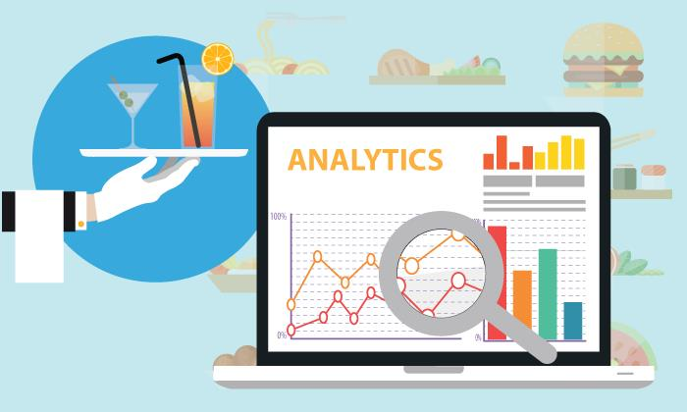

Figure 1.1 Restaurant Analysis

  - OBJECTIVES

- The primary objective is to integrate fragmented data from Point of Sale systems, social media reviews, and inventory logs into a single, unified platform.

- This consolidation eliminates the need for manual data entry and provides a holistic view of the restaurant's health in real-time.

- By applying advanced analytics to historical and current data, the system aims to uncover complex correlations between menu items, staff shifts, and customer satisfaction.

- This allows management to detect subtle performance anomalies that traditional reporting tools frequently overlook.

- The objective is to provide owners with actionable intelligence that explains the "why" behind sales trends rather than just the "what." With these insights, managers can make evidence-based choices regarding menu changes, pricing strategies, and marketing efforts.

  - ADVANTAGES

- Real-time dashboards provide a "single source of truth," allowing owners to monitor revenue, control costs, and make faster, evidence-based decisions rather than relying on gut feelings.

- By analyzing the popularity and profit margins of specific dishes, restaurants can identify "winners" to promote and remove underperforming items that hurt profitability.

- Sentiment analysis of online reviews helps identify specific service gaps—such as recurring complaints on certain nights—enabling targeted fixes that improve satisfaction and loyalty.

- AI-driven tools can accurately predict future sales, inventory needs, and staffing requirements based on historical trends, weather, and local events.

- Intelligence systems help optimize staff scheduling to prevent overstaffing during slow hours and reduce food waste through precise demand forecasting.

CHAPTER 2
LITERATURE SURVEY

2.1 EXISTING PROBLEM

Traditional restaurant management is currently hindered by the fact that critical data remains siloed and reactive, preventing owners from making proactive improvements. While existing systems are capable of recording basic sales and reviews, they suffer from deep-seated inefficiencies, most notably the existence of disconnected data silos where POS data, inventory, and customer feedback are stored in separate, unintegrated tools. This fragmentation forces managers to spend hours manually consolidating information into spreadsheets, a process that is not only time-consuming but also highly prone to human error. Furthermore, basic reporting tools typically provide only a surface-level look at what happened—such as total daily revenue—without explaining the underlying "why," which can mask serious issues like shrinking profit margins or unmonitored food waste.

2.2 PROBLEM STATEMENT

The current problem in restaurant management lies in the fact that critical operational data remains siloed and reactive, preventing owners from making proactive, informed improvements. While existing systems can record basic sales and track customer feedback, they suffer from deep-seated inefficiencies caused by disconnected data silos where POS transactions, inventory levels, and online reviews are stored in separate, unintegrated platforms. This fragmentation forces managers to manually consolidate information into spreadsheets, a process that is both time-consuming and highly susceptible to human error.

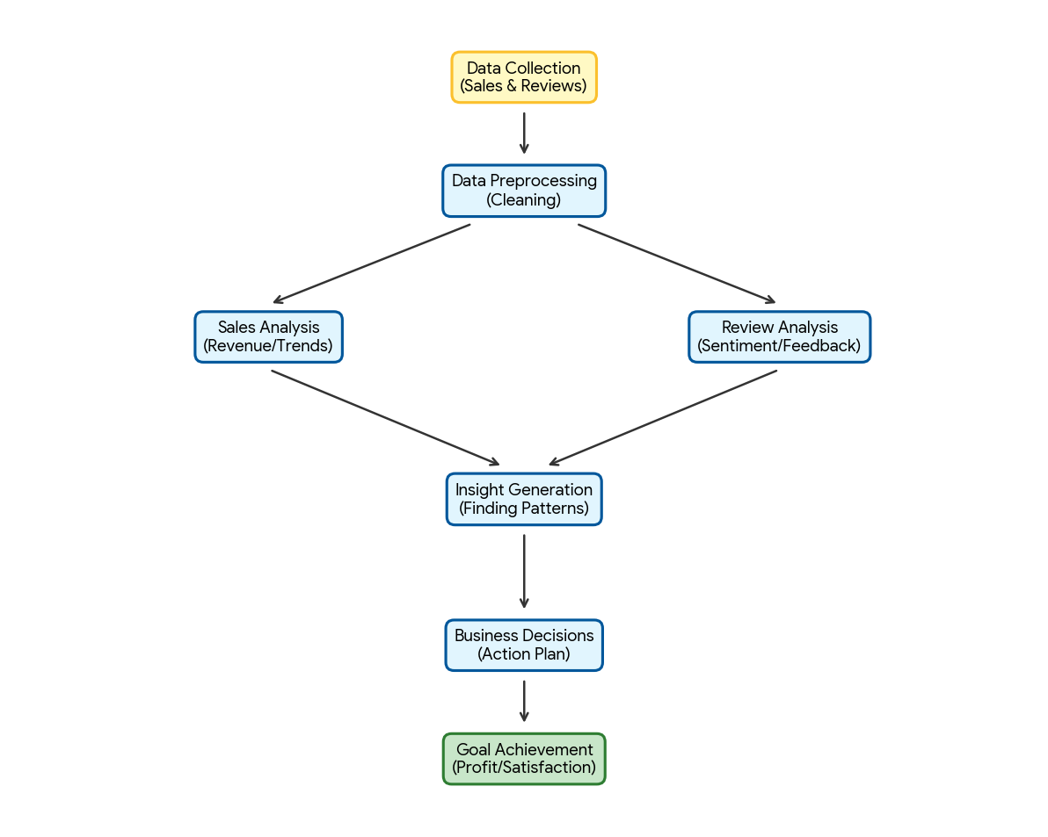

Figure 2.1 Sales Analysis Flowchart

CHAPTER 3
SYSTEM ANALYSIS

3.1Existing System:
The existing systems typically rely on Point of Sale (POS) platforms to record daily sales and manage basic transaction data. These setups are often paired with various online platforms designed specifically for collecting and monitoring customer reviews to gauge public sentiment. To make sense of this information, businesses frequently employ basic reporting tools that generate standard sales summaries and inventory snapshots. However, a significant drawback of these traditional frameworks is their inherent inability to identify complex patterns within the data. Because they rely on static analysis, they often fail to detect subtle anomalies or emerging trends in performance that more advanced systems might catch. This lack of depth means that critical insights often go unnoticed, leaving the business to react to problems rather than anticipating them. Consequently, while these tools handle routine tasks effectively, they struggle to provide the high-level strategic intelligence required for sophisticated decision-making.

3.1.1 LIMITATIONS

      - Training and deploying sophisticated Natural Language Processing (NLP) models, such as Transformers or LSTMs, requires significant computational power.
      - Despite the advancements in Deep Learning, the system may occasionally struggle with the nuances of human language. Restaurant reviews often contain sarcasm or highly localized slang.
      - Consumer behavior and dining trends are constantly evolving. A model trained on data from a year ago may not account for new culinary trends or changes in economic conditions.

3.2 PROPOSED SYSTEM

- The proposed system integrates high-dimensional sales data with unstructured linguistic data from customer reviews using a multi-branch Deep Learning architecture.
- Unlike traditional POS systems that only provide historical reporting, this system utilizes Recurrent Neural Networks (RNNs) and Transformer-based models to identify latent correlations between service speed, food quality, and overall revenue.
- The architecture is designed to handle real-time data ingestion, allowing for immediate anomaly detection and automated strategic recommendations for restaurant management.
- By implementing a backend powered by FastAPI, the system processes structured data from POS (Point of Sale) systems and unstructured data from digital review platforms. The core of the system is an AI engine that uses Natural Language Processing (NLP) to perform fine-grained sentiment analysis.
- This allows the business to not only see that sales are down, but to understand why—linking revenue dips to specific keywords like "long wait times," "salty food," or "poor service."

  - ADVANATGES

- Real-time dashboards provide a "single source of truth," allowing owners to monitor revenue, control costs, and make faster, evidence-based decisions rather than relying on gut feelings.
- By analyzing the popularity and profit margins of specific dishes, restaurants can identify "winners" to promote and remove underperforming items that hurt profitability.

- Sentiment analysis of online reviews helps identify specific service gaps—such as recurring complaints on certain nights—enabling targeted fixes that improve satisfaction and loyalty.

- AI-driven tools can accurately predict future sales, inventory needs, and staffing requirements based on historical trends, weather, and local events.

- Intelligence systems help optimize staff scheduling to prevent overstaffing during slow hours and reduce food waste through precise demand forecasting.

CHAPTER 4
SYSTEM REQURIMENTS
  - HARDWARE REQUIREMENTS
    - Processor: Minimum Intel Core i3 or higher for smooth data processing
    - RAM: At least 4 GB (8 GB recommended for better performance)
    - Storage: Minimum 100 GB hard disk or SSD for storing datasets and results
    - System Type: 64-bit computer or laptop
    - Internet Connection: Stable internet for accessing social media APIs and data collection
  - SOFTWARE REQUIREMENTS

Python 3.10+:
Python is the primary programming language used for developing the entire application. It is chosen because of its simplicity, readability, and strong ecosystem of libraries for data analysis, database handling, and Natural Language Processing (NLP). Python allows seamless integration of all components such as data processing, machine learning, and dashboard development in a single environment.

SQLite:
SQLite is a lightweight database systems used as the BI data warehouse. They do not require complex server setup and can run locally, making them ideal for small-scale projects. These databases efficiently store structured return data and support SQL queries for analysis, enabling quick data retrieval and aggregation.

Pandas:
Pandas is a powerful Python library used for data manipulation and analysis. It helps in cleaning, transforming, and aggregating return data. Pandas enables easy handling of

tabular data and is used to generate insights such as return trends, category-wise analysis, and summary statistics.
NLTK:
NLTK is used for text preprocessing tasks such as tokenization, stop-word removal, and stemming. It helps in cleaning and preparing unstructured social media data for accurate sentiment analysis.

TextBlob:
TextBlob is used for performing sentiment analysis. It provides simple APIs to classify text into positive, negative, or neutral sentiments, making it suitable for beginner-friendly NLP implementation.

Power BI:
Power BI is used to create interactive dashboards and visualizations. It converts processed data into meaningful insights such as sentiment distribution, trends, and engagement metrics.

Twitter API:
Twitter API is used to collect real-time social media data related to the brand. It allows access to tweets, hashtags, and user interactions for analysis.

Jupyter Notebook / VS Code:
These development environments are used for writing and testing code. Jupyter Notebook is useful for experimentation and visualization, while VS Code provides a full-featured coding environment.
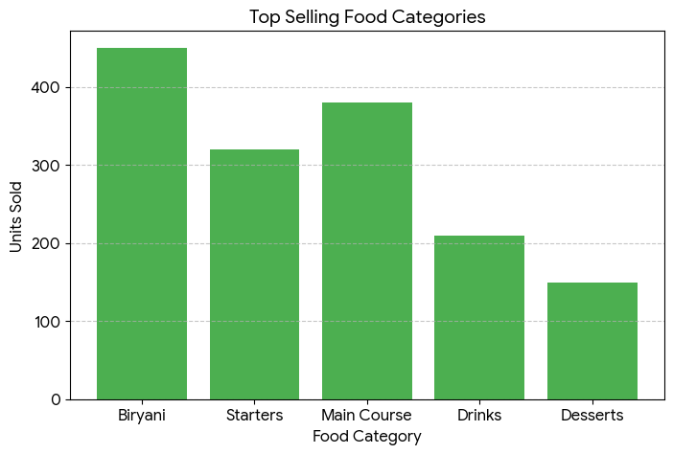
Figure 4.1 Restaurant Sales Performance

CHAPTER 5 IMPLEMENTATION
  - PROGRAM IMPLEMENTATION CODE :

BACKEND CODE:

from fastapi import FastAPI, HTTPException, Query
from fastapi.middleware.cors import CORSMiddleware
from pydantic import BaseModel
from typing import Optional, List
from datetime import datetime, date, timedelta
import random
import json

app = FastAPI(title="Forno BI API", version="1.0.0", description="Restaurant Intelligence Platform")

app.add_middleware(
CORSMiddleware,
allow_origins=["*"],
allow_credentials=True,
allow_methods=["*"],
allow_headers=["*"],
)

#Mock Data
MENU_ITEMS = [
{"id": 1, "name": "Truffle Pasta", "category": "Main", "price": 1200, "food_cost_pct": 22, "margin_pct": 68},
{"id": 2, "name": "Burrata Salad", "category": "Starter", "price": 650, "food_cost_pct": 24, "margin_pct": 74},
{"id": 3, "name": "Bistecca Fiorentina", "category": "Main", "price": 2800, "food_cost_pct": 38, "margin_pct": 51},
{"id": 4, "name": "Tiramisu", "category": "Dessert", "price": 450, "food_cost_pct": 14, "margin_pct": 81},
{"id": 5, "name": "Negroni", "category": "Bar", "price": 750, "food_cost_pct": 18, "margin_pct": 79},
{"id": 6, "name": "Risotto al Funghi", "category": "Main", "price": 950, "food_cost_pct": 26, "margin_pct": 64},
{"id": 7, "name": "Bruschetta", "category": "Starter", "price": 320, "food_cost_pct": 20, "margin_pct": 76},
{"id": 8, "name": "Panna Cotta", "category": "Dessert", "price": 380, "food_cost_pct": 16, "margin_pct": 79},
{"id": 9, "name": "Aperol Spritz", "category": "Bar", "price": 620, "food_cost_pct": 19, "margin_pct": 77},
{"id": 10,"name": "Kids Pasta", "category": "Kids", "price": 280, "food_cost_pct": 32, "margin_pct": 38},
]

REVIEWS = [
{"id": 1, "name": "Priya S.", "stars": 5, "date": "2025-12-29", "text": "Truffle pasta was absolutely divine — best Italian in Chennai!", "sentiment": "positive", "platform": "Google"},
{"id": 2, "name": "Rahul K.", "stars": 2, "date": "2026-01-29", "text": "Waited 45 minutes even with reservation. Coordination needs serious improvement.", "sentiment": "negative", "platform": "Zomato"},
{"id": 3, "name": "Ananya M.", "stars": 5, "date": "2026-03-28", "text": "Celebrated anniversary here. Staff made it magical, tiramisu was perfection.", "sentiment": "positive", "platform": "Google"},
{"id": 4, "name": "Vikram N.", "stars": 3, "date": "2026-04-28", "text": "Food was great but place was too loud. Hard to have a conversation on Friday.", "sentiment": "neutral", "platform": "Swiggy"},
{"id": 5, "name": "Deepa R.", "stars": 5, "date": "2026-02-25", "text": "Arjun was an incredible server — attentive without hovering. Will definitely return!", "sentiment": "positive", "platform": "Google"},
{"id": 6, "name": "Suresh P.", "stars": 4, "date": "2025-12-27", "text": "Burrata knocked it out of the park. Bistecca slightly overcooked but still enjoyable.", "sentiment": "positive", "platform": "Zomato"},
{"id": 7, "name": "Kavya B.", "stars": 1, "date": "2025-11-26", "text": "Wrong order brought and manager was dismissive when we flagged it. Unacceptable.", "sentiment": "negative", "platform": "Google"},
{"id": 8, "name": "Arun T.", "stars": 5, "date": "2025-12-25", "text": "Bar program is exceptional. Best Negroni I've had in India. James is outstanding!", "sentiment": "positive", "platform": "Swiggy"},
{"id": 9, "name": "Meera L.", "stars": 4, "date": "2026-04-25", "text": "Risotto was creamy and perfect. Good wine list, slightly pricey but worth it.", "sentiment": "positive", "platform": "Google"},
{"id": 10, "name": "Kiran J.", "stars": 2, "date": "2026-10-25", "text": "Reservation for 8pm, seated at 8:45. No apology, no compensation. Very disappointed.", "sentiment": "negative", "platform": "Zomato"},
{"id": 11, "name": "Pooja G.", "stars": 5, "date": "2026-04-24", "text": "Perfect for a special occasion. Beautiful ambiance and the pasta is exceptional.", "sentiment": "positive", "platform": "Google"},
{"id": 12, "name": "Sanjay M.", "stars": 3, "date": "2026-03-24", "text": "Average experience. Food was good but service felt rushed. Expected more for the price.", "sentiment": "neutral", "platform": "Swiggy"},
]

STAFF = [
{"id": 1, "name": "Arjun", "role": "Head Server", "covers": 284, "avg_check": 1620, "tips": 22400, "rating": 4.9, "status": "top"},
{"id": 2, "name": "James ", "role": "Head Bartender", "covers": 0, "avg_check": 0, "tips": 30200, "rating": 4.8, "status": "excellent"},
{"id": 3, "name": "Maria", "role": "Server", "covers": 198, "avg_check": 1540, "tips": 16400, "rating": 4.6, "status": "good"},
{"id": 4, "name": "Lena ", "role": "Host", "covers": 842, "avg_check": 0, "tips": 0, "rating": 4.7, "status": "excellent"},
{"id": 5, "name": "Kevin Pillai", "role": "Server", "covers": 156, "avg_check": 1380, "tips": 12700, "rating": 4.2, "status": "average"},
{"id": 6, "name": "Ravi Shankar", "role": "Server", "covers": 122, "avg_check": 1320, "tips": 9600, "rating": 3.9, "status": "needs_coaching"},
]

RESERVATIONS = [
{"id": 1, "time": "19:00", "guest": "Sharma, A.", "party": 4, "table": "T-08", "source": "Dineout", "status": "seated", "notes": "Anniversary"},
{"id": 2, "time": "19:15", "guest": "Iyer, S.", "party": 2, "table": "T-03", "source": "Website", "status": "seated", "notes": "VIP guest"},
{"id": 3, "time": "19:30", "guest": "Patel, R.", "party": 6, "table": "T-12", "source": "Phone", "status": "waiting", "notes": "Jain food req."},
{"id": 4, "time": "20:00", "guest": "Krishnan, C.", "party": 3, "table": "T-06", "source": "Dineout", "status": "confirmed", "notes": "—"},
{"id": 5, "time": "20:30", "guest": "Nair, H.", "party": 8, "table": "T-14", "source": "Website", "status": "risk", "notes": "Large group"},
{"id": 6, "time": "21:00", "guest": "Verma, L.", "party": 2, "table": "T-02", "source": "Phone", "status": "confirmed", "notes": "Regular guest"},
]

def generate_daily_revenue(days=7, base=65000):
multipliers = [0.72, 0.68, 0.78, 0.82, 1.05, 1.35, 0.95]
today = date.today()
return [
{
"date": (today - timedelta(days=days-1-i)).isoformat(),
"day": (today - timedelta(days=days-1-i)).strftime("%a"),
"revenue": int(base * multipliers[i % 7] * random.uniform(0.92, 1.08)),
"covers": int(120 * multipliers[i % 7] * random.uniform(0.9, 1.1)),
}
for i in range(days)
]

def get_weekly_metrics():
daily = generate_daily_revenue(7)
prev_daily = generate_daily_revenue(7, base=59000)

FRONTEND CODE:

<!DOCTYPE html>
<html lang="en">
<head>
<meta charset="UTF-8">
<meta name="viewport" content="width=device-width, initial-scale=1.0">
<title>Forno BI — Restaurant Intelligence Platform</title>
<link rel="preconnect" href="https://fonts.googleapis.com">
<link href="https://fonts.googleapis.com/css2?family=DM+Serif+Display:ital@0;1&family=DM+Sans:ital,wght@0,300;0,400;0,500;0,600;1,400&display=swap" rel="stylesheet">
<script src="https://cdnjs.cloudflare.com/ajax/libs/Chart.js/4.4.1/chart.umd.js"></script>
<style>
*{box-sizing:border-box;margin:0;padding:0}
:root{
--bg:#0d0d0f;--bg2:#141416;--bg3:#1a1a1e;--bg4:#222228;
--border:#2a2a32;--border2:#333340;
--text:#f0ede8;--text2:#9b9aaa;--text3:#5a5968;
--accent:#e8795a;--accent2:#f0a882;--accent3:#c45e42;
--green:#52c48a;--blue:#5a9cf5;--amber:#f5c842;--red:#e8605a;
--purple:#a06cdb;
--fs:'DM Sans',sans-serif;--fd:'DM Serif Display',serif;
}
html,body{height:100%;background:var(--bg);color:var(--text);font-family:var(--fs);font-size:14px;line-height:1.5}
.app{display:flex;height:100vh;overflow:hidden}
<div class="app">

<!-- MAIN -->
<main class="main">
<div class="topbar">
<div class="pt" id="pageTitle">Overview Dashboard</div>
<div class="tbr">
<div class="badge-date" id="todayDate"></div>
<div class="tabs">
<button class="tab active" onclick="setPeriod('week',this)">Week</button>
<button class="tab" onclick="setPeriod('month',this)">Month</button>
<button class="tab" onclick="setPeriod('year',this)">Year</button>
</div>
<div class="cc-hdr"><div class="cc-title">Revenue Mix</div><div class="cc-sub">By category</div></div>
<div style="position:relative;height:190px"><canvas id="c-mix"></canvas></div>
</div>
</div>
<div class="ai-box">
<div class="ai-hdr"><div class="ai-dot"></div><div class="ai-ttl">AI Intelligence — Ask About Your Restaurant</div></div>
</script>
</body>
</html>

OUTPUT :

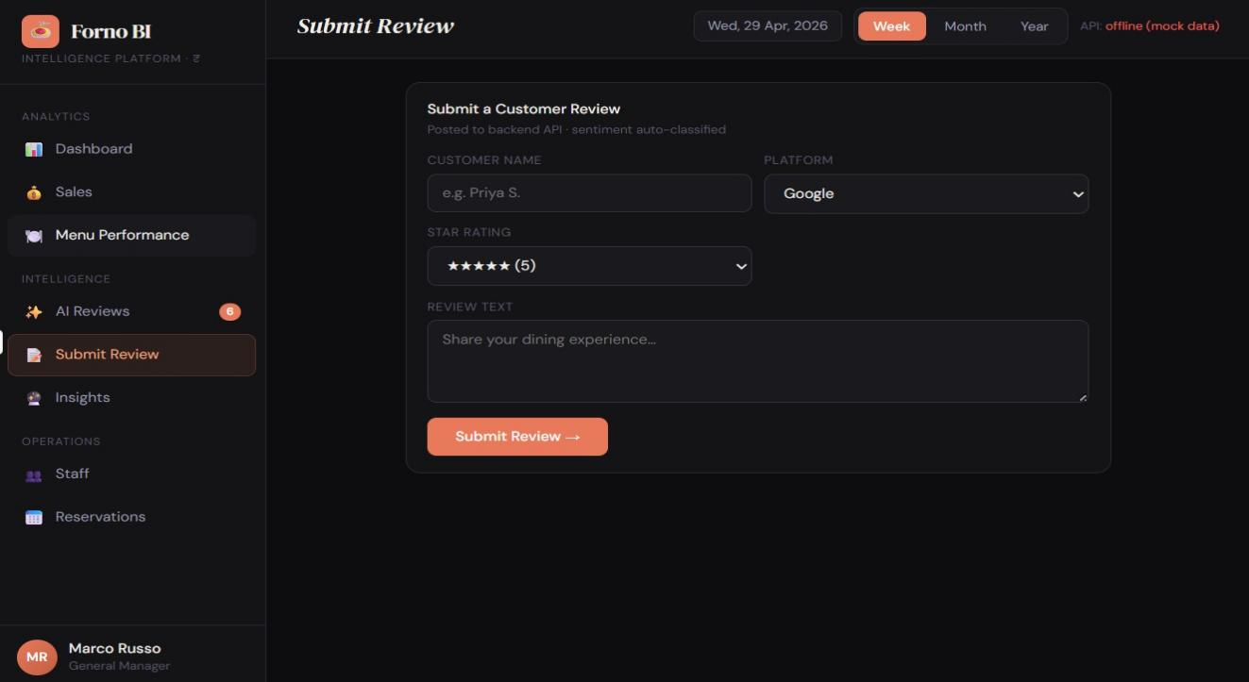

Figure 5.2 Customer Review Page

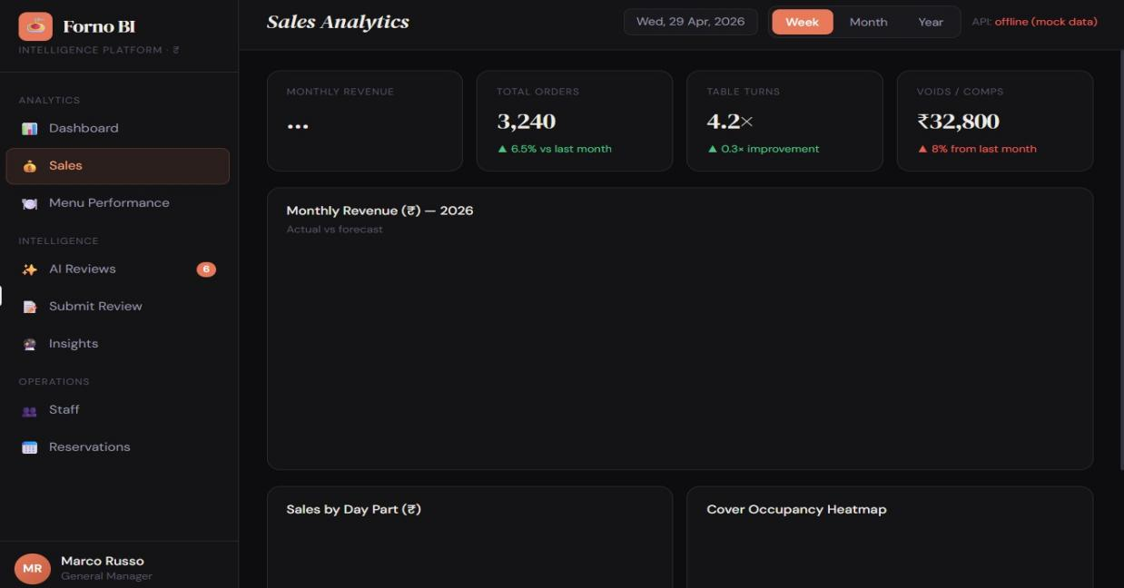

Figure 5.3 Sales Analytics Page

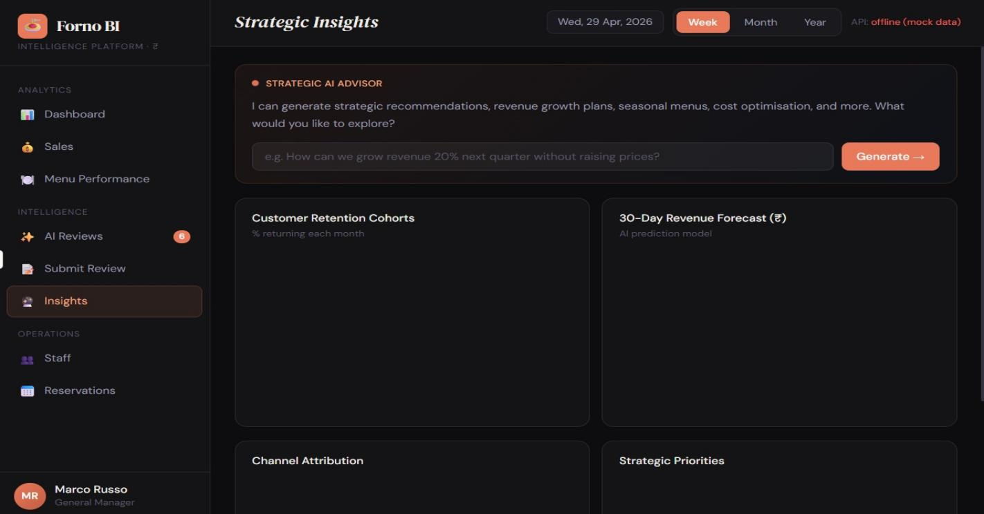

Figure 5.4 Strategic Insights Page

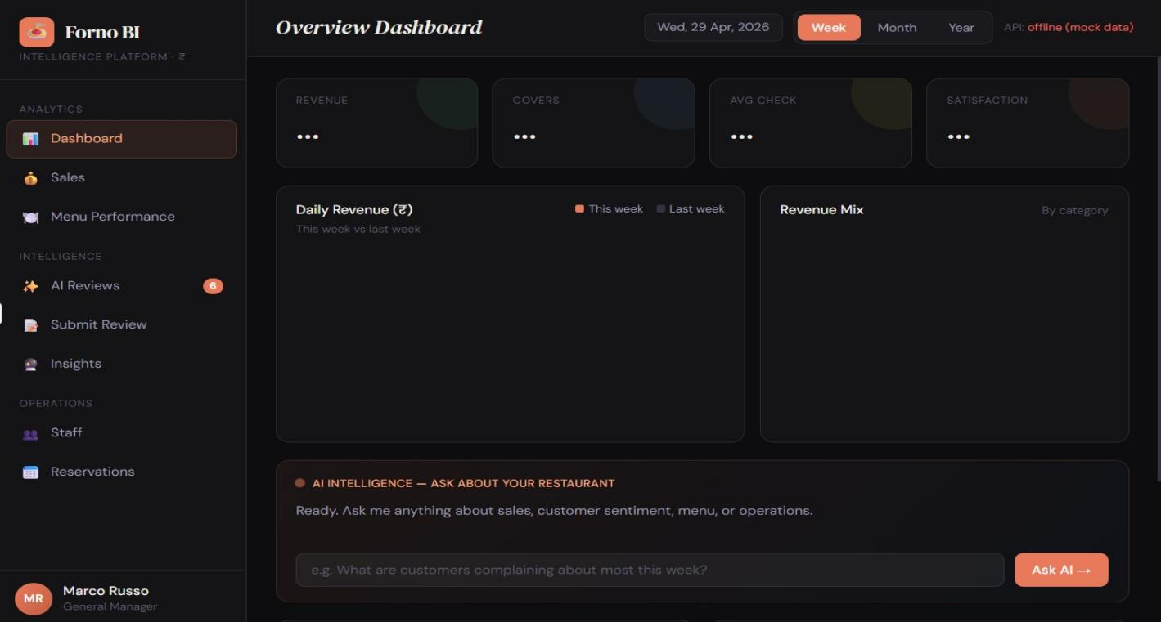

Figure 5.5 Dashboard Page

CHAPTER 6
CONCLUSION AND FUTURE ENHANCEMENT

6.1 Conclusion:

- The methodology successfully transforms raw restaurant data into meaningful insights using AI and data analytics. By integrating sales and review analysis, the system enables better decision-making, improves customer satisfaction, and increases profitability.

- In addition, the proposed Restaurant Sales and Review Intelligence system provides a scalable and efficient platform for modern restaurant management. The use of machine learning and sentiment analysis helps identify customer preferences, service quality issues, and trending food items in real time.

- Visual dashboards and analytical reports allow restaurant owners and managers to monitor business performance effectively and make data-driven strategies for marketing, inventory management, and customer engagement. Furthermore, the system reduces manual effort in analyzing large volumes of customer feedback and sales records, thereby improving operational efficiency and supporting continuous business growth in the competitive restaurant industry.

- Moreover, the system can be further enhanced by integrating advanced technologies such as predictive analytics, recommendation systems, and cloud-based data storage. Predictive models can forecast future sales trends and customer demands, helping restaurants optimize staffing, reduce food wastage, and improve resource allocation.

- Integration with mobile applications and online food delivery platforms can also provide real-time customer interaction and personalized recommendations.

6.2Future Enhancement:

we can focus on improving the intelligence, scalability, and accessibility of the system. Real-time data streaming integration can help restaurants monitor live sales transactions, customer feedback, and operational performance instantly for faster decision-making.

Advanced deep learning models such as LSTM, BERT, and transformer-based sentiment analysis can provide more accurate understanding of customer emotions and opinions from reviews.

A mobile-based dashboard will allow restaurant owners and managers to access analytics, reports, and alerts anytime and anywhere through smartphones.

    - Multi-location restaurant support can enable centralized monitoring and comparison of branches, helping businesses maintain consistent quality and performance across different locations.

    - Additionally, voice assistant and chatbot integration can enhance customer interaction by providing automated query handling, personalized recommendations, table booking support, and instant feedback collection, thereby creating a smarter and more interactive restaurant management ecosystem.

REFERENCES

  - FastAPI Modern Web Development – Bill Lubanovic
https://www.oreilly.com/library/view/fastapi-modern-web/9781098135492/
  - Designing Data-Intensive Applications – Martin Kleppmann
https://dataintensive.net/
  - Building Microservices – Sam Newman
https://samnewman.io/books/building_microservices/
  - Python for Data An alysis – Wes McKinney
https://wesmckinney.com/book/
  - Data Science for Business
https://www.oreilly.com/library/view/data-science-for/9781449374273/
  - Storytelling with Data
https://www.storytellingwithdata.com/book
  - LHands-On Machine Learning with Scikit-Learn, Keras, and TensorFlow
https://www.oreilly.com/library/view/hands-on-machine-learning/9781492032632/
  - Restaurant Management: Customers, Operations, and Employees
https://www.pearson.com/en-us/subject-catalog/p/restaurant-management-customers-operations-and-employees/P200000003094
  - Business Intelligence Guidebook
https://www.elsevier.com/books/business-intelligence-guidebook/sherman/978-0-12-411461-6
  - Fundamentals of Database Systems
https://www.pearson.com/en-us/subject-catalog/p/fundamental/

